**Lab 5. Data Manipulation Language**

**1. Create Employee table with same structure as EMP table.**

**SQL>Create table employee as select * from emp where 1=3**

**SQL>desc employee**

**Name Null? Type**

**EMPNO NOT**

**NULL NUMBER(4)**

**ENAME VARCHAR2(10)**

**JOB VARCHAR2(50)**

**MGR NUMBER(4)**

**HIRE DATE DATE**

**SAL NUMBER(7,2)**

**COMM NUMBER(7,2)**

**DEPTNO NUMBER(2)**

CREATE TABLE EMPLOYEE AS SELECT * FROM EMP WHERE 1=3; DESC EMPLOYEE;

SELECT * FROM EMPLOYEE;

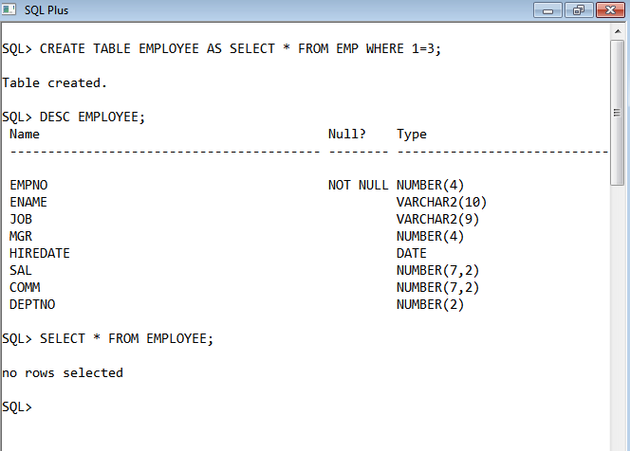

**2. Write a query to populate Employee table using EMP table’s empno, ename, sal,**

**deptno columns.**

**EMPNO ENAME JOB MGR HIREDATE SAL COMM DEPTNO**

**7369 SMITH 800 20**

**7499 ALLEN 1600 30**

**7521 WARD 1250 30**

**7566 JONES 2975 20**

**7654 MARTIN 1250 30**

**7698 BLAKE 2850 30**

**7782 CLARK 2450 10**

**7788 SCOTT 3000 20**

**7839 KING 5000 10**

**7844 TURNER 1500 30**

**7876 ADAMS 1100 20**

**7900 JAMES 950 30**

**7902 FORD 3000 20**

**7934 MILLER 1300 10**

INSERT INTO EMPLOYEE(EMPNO,ENAME,SAL,DEPTNO) SELECT EMPNO,ENAME,SAL,DEPTNO FROM EMP;

SELECT * FROM EMPLOYEE;

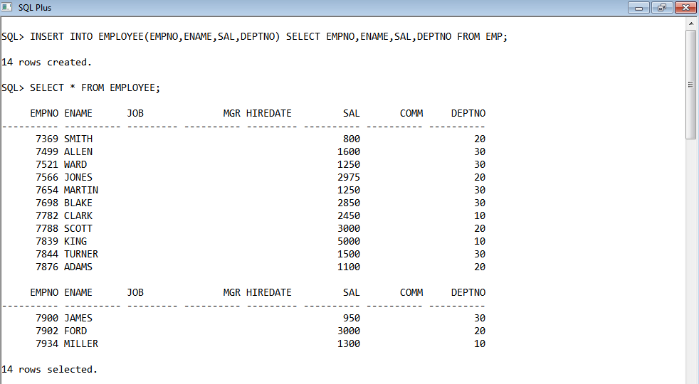

**3. Write a query to change the job and deptno of employee whose empno is 7698 to**

**the job and deptno of employee having empno 7788.**

UPDATE EMP SET (JOB,DEPTNO)= (SELECT JOB,DEPTNO FROM EMP WHERE EMPNO=7788) WHERE EMPNO=7698;

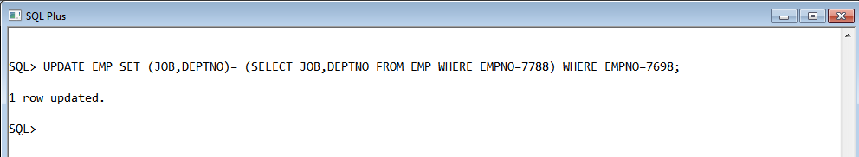

**4. Delete the details of department whose department name is ‘SALES’.**

DELETE FROM EMP WHERE JOB='SALESMAN';

SELECT * FROM EMP;

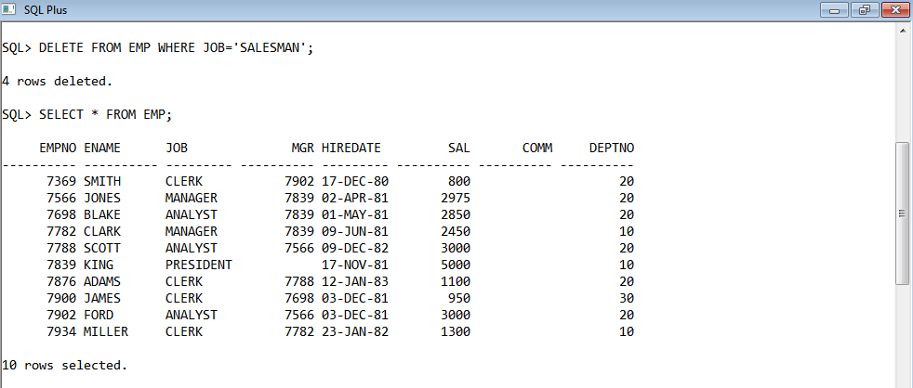

**5. Write a query to change the deptno of employee with empno 7788 to that of employee having empno 7698.**

UPDATE EMP SET DEPTNO=(SELECT DEPTNO FROM EMP WHERE EMPNO=7698) WHERE EMPNO=7788;

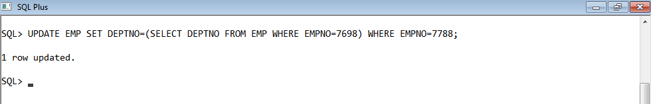

**6. Insert the following rows to the Employee table through parameter substitution.**

**• 1000,Allen, Clerk,1001,12-jan-01, 3000, 2,10**

**• 1001,George, analyst, null, 08 Sep 92, 5000,0, 10**

**• 1002, Becker, Manager, 1000, 4 Nov 92, 2800,4, 20**

**• 1003, 'Bill', Clerk, 1002, 4 Nov 92,3000, 0, 20**

INSERT INTO EMPLOYEE VALUES(&EMPNO,'&ENAME','&JOB',&MGR,TO_DATE('&HIREDATE','DD-MON-YY'),&SAL,&COMM,&DEPTNO);

INSERT INTO EMPLOYEE VALUES(&EMPNO,'&ENAME','&JOB',&MGR,TO_DATE('&HIREDATE','DD-MON-YY'),&SAL,&COMM,&DEPTNO);

INSERT INTO EMPLOYEE VALUES(&EMPNO,'&ENAME','&JOB',&MGR,TO_DATE('&HIREDATE','DD-MON-YY'),&SAL,&COMM,&DEPTNO);

INSERT INTO EMPLOYEE VALUES(&EMPNO,'&ENAME','&JOB',&MGR,TO_DATE('&HIREDATE','DD-MON-YY'),&SAL,&COMM,&DEPTNO);

INSERT INTO EMPLOYEE VALUES(&EMPNO,'&ENAME','&JOB',&MGR,TO_DATE('&HIREDATE','DD-MON-YY'),&SAL,&COMM,&DEPTNO);

SELECT * FROM EMPLOYEE;

